**Azure data bricks Assessment 3 :** - Abhiram Basa

Today we did hands on practice on how to create visualizations like bar graphs, pie charts, etc. For particular data.

**Creating new visualizations:**

In order to create visualizations, we need to have data.

Here I provided a data and used display() method.

* After creating a table
* Click on + symbol
* Click on visualization.
* Select the type of visualization, here I selected “Scatter”

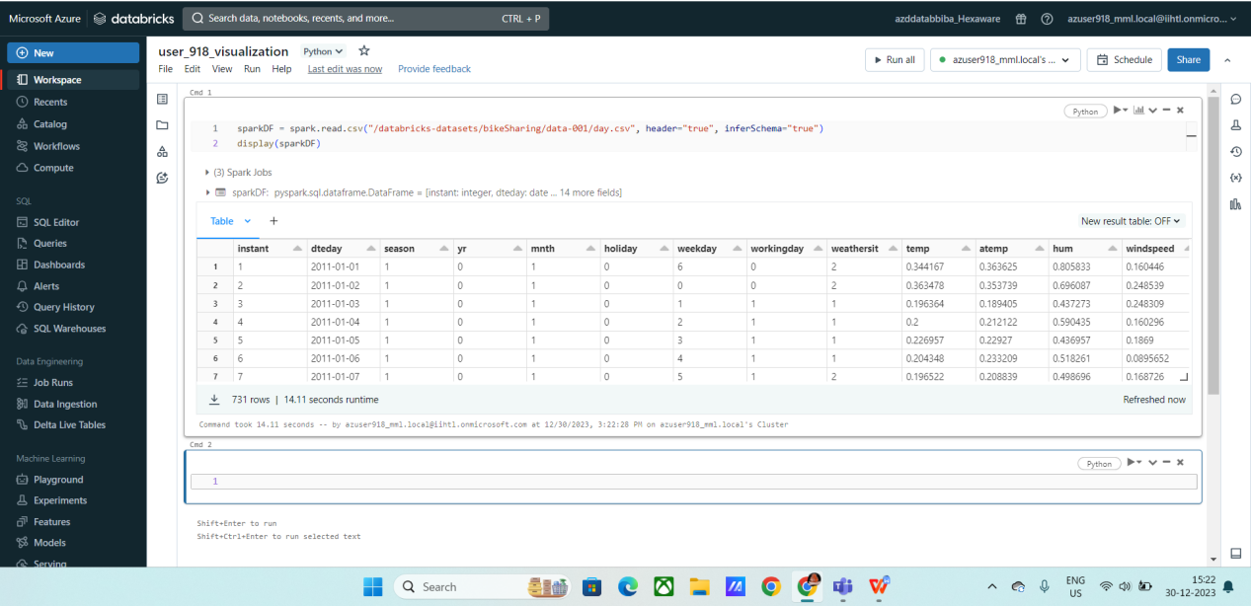

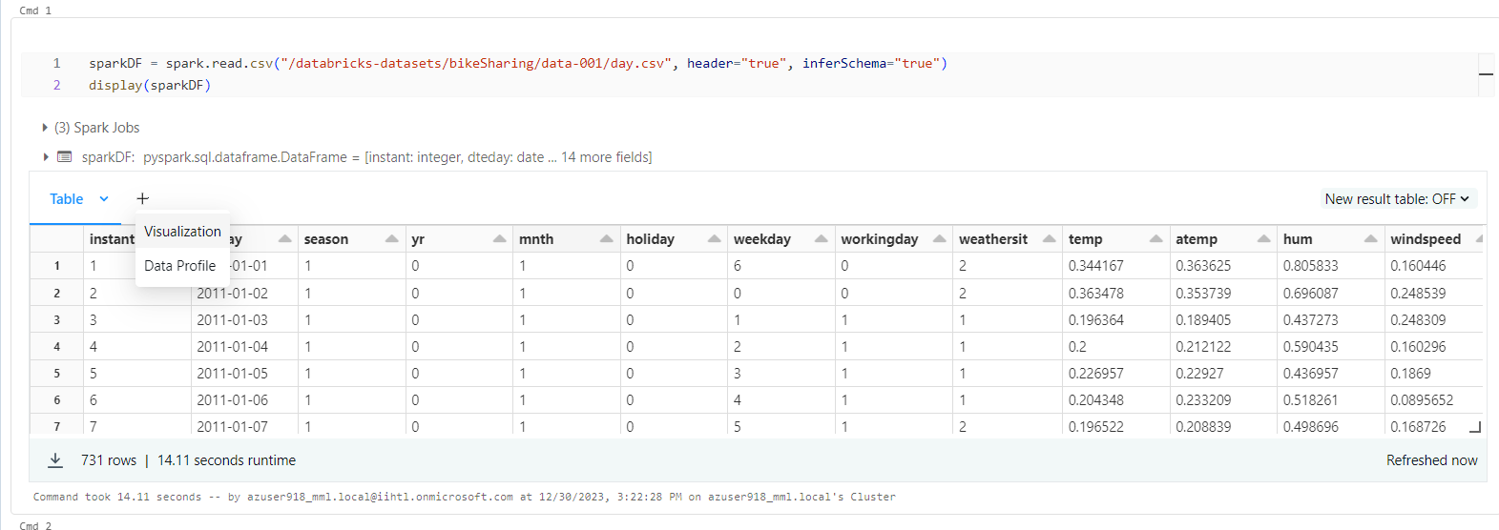

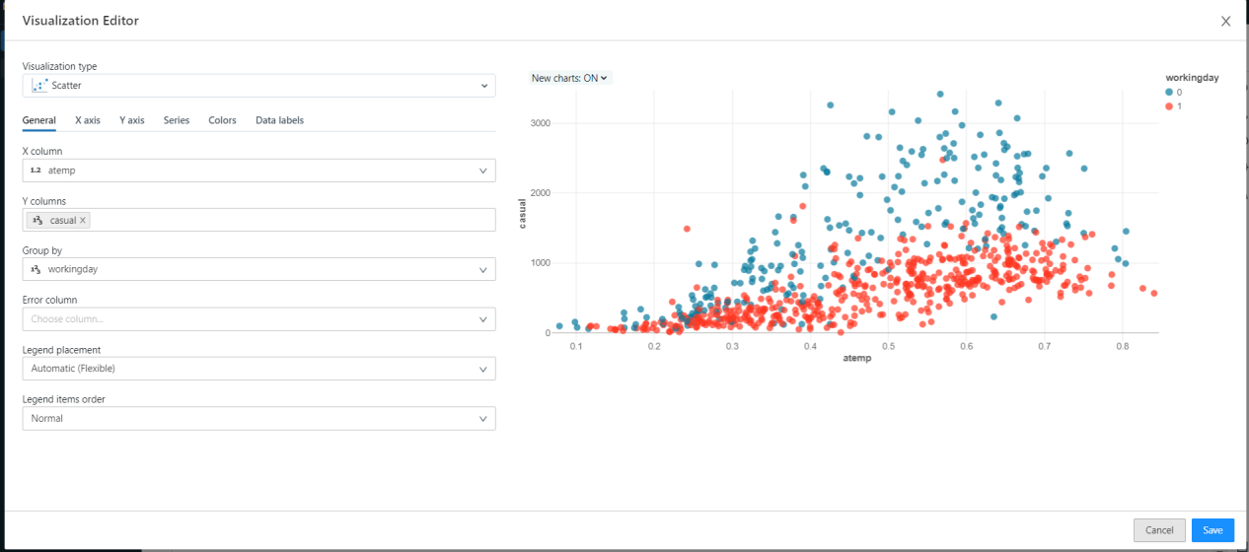

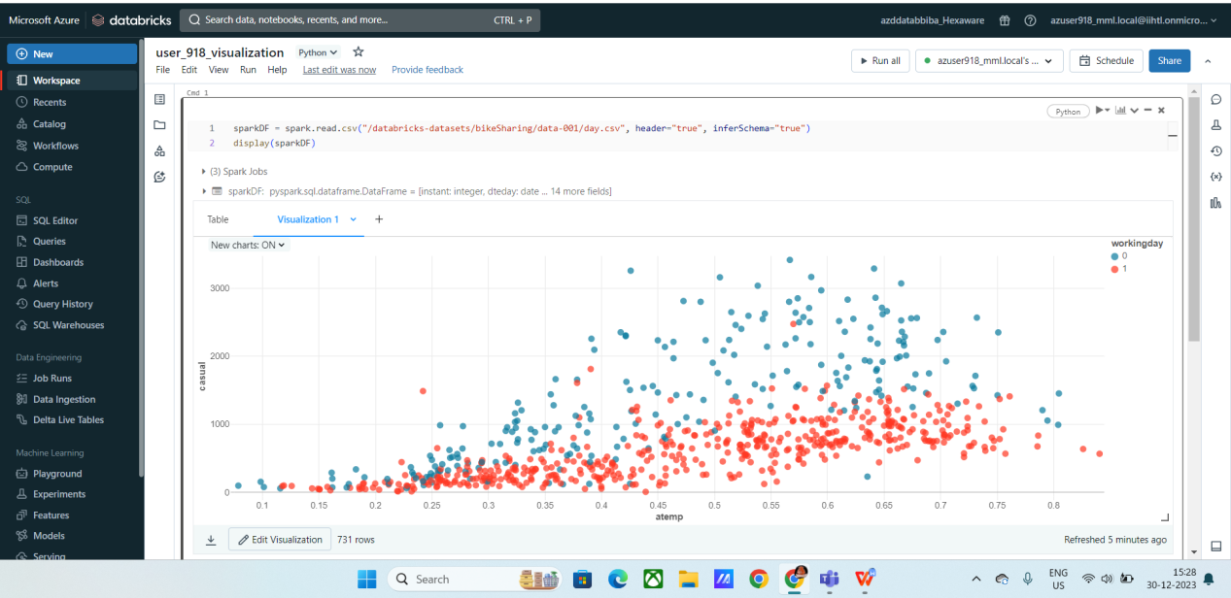

You can also change the color of the chart visualization by clicking “edit” on the bottom left corner.

You can edit , delete , view and download you visualization charts.

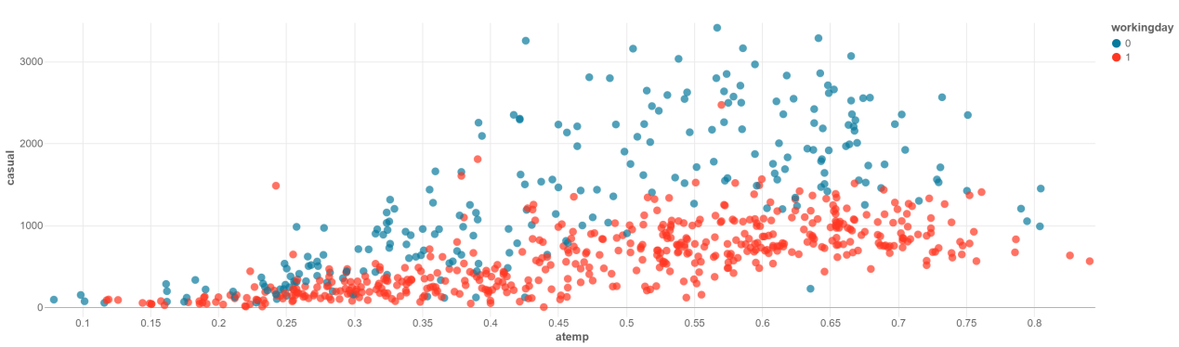

After creating the visualization, we can also create data profile.

**Data profile :** Used to analyse the data based on some trends, you can also order and filter the data.

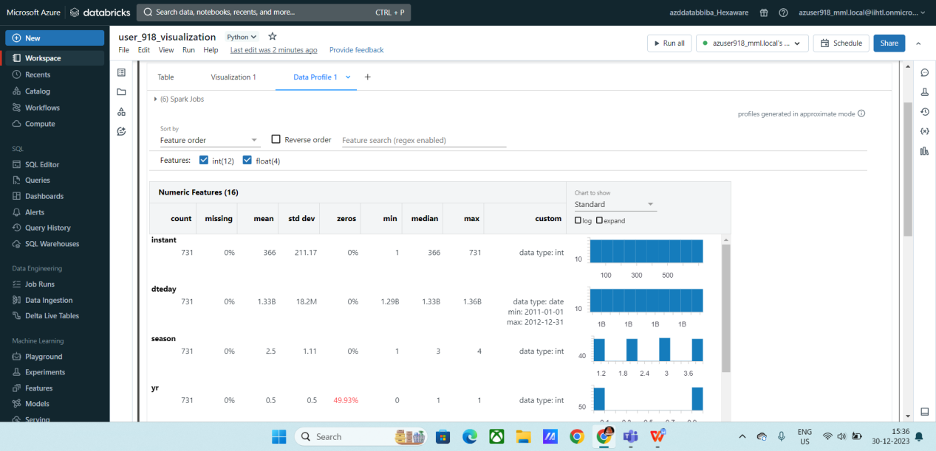

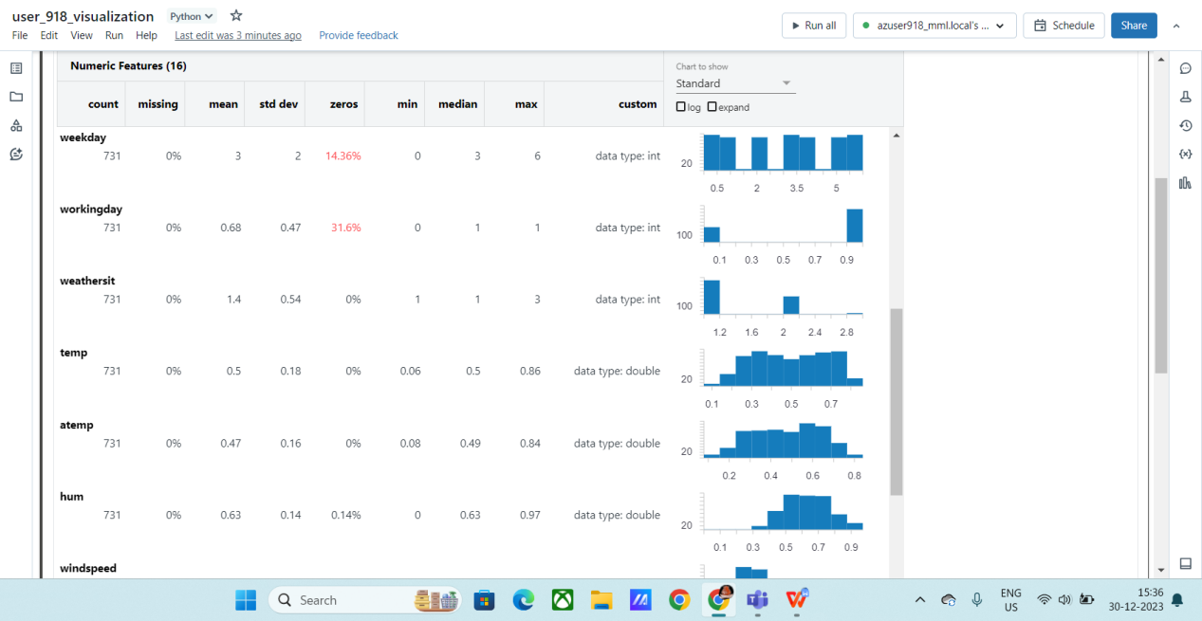

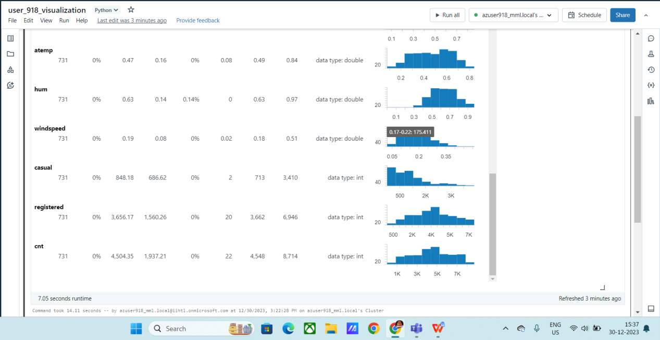

We created Table, visualization and data profile from the data using Azure data bricks.